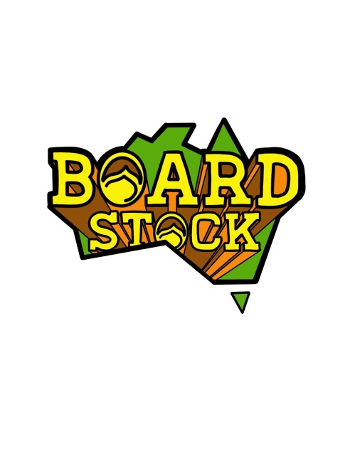
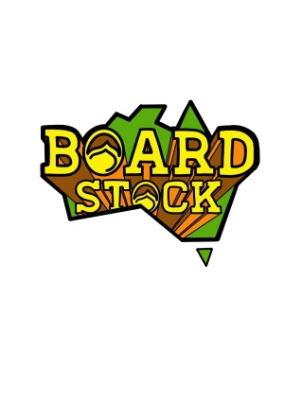
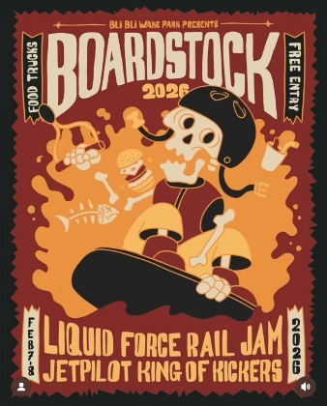

February 7th & 8th
The Events
In 2026 there will be 2 contest events at Bli Bli Watersports.

The JET PILOT King of the Kickers Event will be staged on the front lake from 2pm Saturday using 2 new L UNIT kickers. Both kickers will be positioned on the right side of the cable, one before the motor tower and one after the motor tower. Divisions will include Under 10 boys and Girls (reduced speed), Under 13 Boys and Girls, Under 17 Boys and Girls, Amateur Men and Women, and Pro Men and Women.
Presentations will immediately follow the completion of the event with a sausage sizzle/BBQ….
The LIQUID FORCE Features Event will be staged on the front lake from 8am Sunday using all available rails and kickers, as well as a seperate section for Water Tricks or ‘the bump”…. plus some new “lines” for the pro’s…Divisions will include Under 10 Boys and Girls (reduced speed), Under 13 Boys and Girls, Under 17 Boys and Girls, Amateur Men and Women, Dodgy Dads, Wake n Cakers, Wakeskate pro and Amateur, plus Pro Men and Women.
Presentations will immediately follow the completion of the event
Rules and Judging guidelines/mud maps will be posted online prior to the event and available on site or by request
The Proposed Schedule
February 7th & 8th

Saturday 8am – Official practise sessions on the Features course
Saturday 12pm – Practice on the King of Kickers Course
Saturday 2pm – King of the Kickers Contest
Saturday 6pm – King of the Kickers Presentation
Saturday 6pm to 7pm – Sausage sizzle/BBQ

. Sunday 8am – Features Only Contest
Saturday 3pm – Features Only Presentation
Saturday 4pm – End of Contest

All times are SUBJECT TO CHANGE!!! (at the discretion of the event organisers)
It is the riders responsibility to know when and where their events are taking place
Updates will be posted on the “Boardstock” social media Instagram pages

