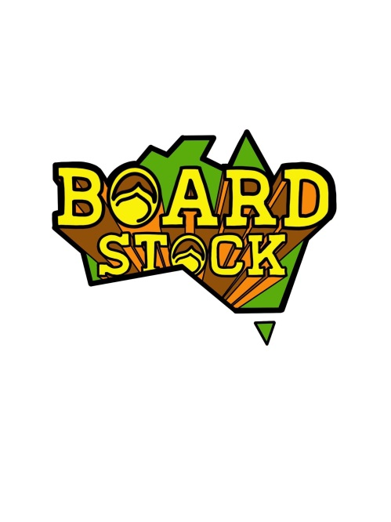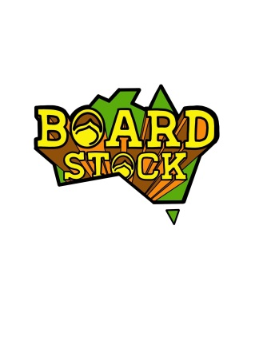

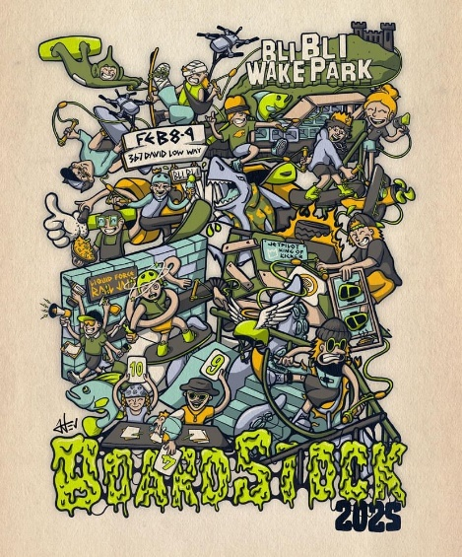

**February 8th & 9th**

**The Events**

In 2025 there will be 2 contest events at Bli Bli Watersports.

The ***JET PILOT*** **King of the Kickers Event** will be staged on the front lake from 2pm Saturday 2025 using dual kickers. Both kickers will be positioned on the right side of the cable, one before the motor tower and one after the motor tower. Divisions will include Under 10 boys and Girls (reduced speed), Under 13 Boys and Girls, Under 17 Boys and Girls, Amateur Men and Women, and Pro Men and Women.

Presentations will immediately follow the completion of the event with a sausage sizzle/BBQ….

The ***LIQUID FORCE*** **Features Event** will be staged on the front lake from 8am Sunday 2025 using all the rails and kickers, as well as a new section for Water Tricks or ‘the bump”…. plus some new “lines” for the pro’s…Divisions will include Under 10 Boys and Girls (reduced speed), Under 13 Boys and Girls, Under 17 Boys and Girls, Amateur Men and Women, Dodgy Dads, Wakeskate pro and Amateur, plus Pro Men and Women.

Presentations will immediately follow the completion of the event

Rules and Judging guidelines/mud maps will be available on site or by request

**The Proposed Schedule**

**February 8th & 9th**

**Saturday 12pm** – Practice on the Kickers Course

**Saturday 2pm** – King of the Kickers Contest

**Saturday 6pm** – King of the Kickers Presentation

**Saturday 6pm to 7pm** – Sausage sizzle/BBQ

***.* Sunday 8am** – Features Only Contest

**Saturday 3pm** – Features Only Presentation

**Saturday 4pm** – End of Contest

**All times are SUBJECT TO CHANGE!!! (at the discretion of the event organisers)**

*It is the riders responsibility to know when and where their events are taking place*

*Updates will be posted on the “Boardstock” social media Instagram pages*