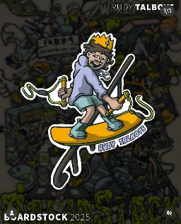

Official Boardstock Practice Sessions
ALL Practice sessions take place on the Front Lake

Tuesday February 4 4pm to 6pm – King of the Kicker practice session Std speed
Wednesday February 5 5pm to 6pm – Std speed – Under 13 and Under 17 ONLY
Thursday February 6 5pm to 6pm – SLOW speed – Under 10 Boys and Girls ONLY
Friday February 7 1pm to 2pm – SLOW speed – Under 10 Boys and Girls ONLY
Friday February 7 5pm to 6pm – Std speed – Amateur Men & Women, Wakeskate, Pro Men & Women
Saturday February 8 8am to 9am – SLOW speed – Under 10 Boys and Girls ONLY
Saturday February 8 9am to 10am – Std speed – Under 13 and Under 17 Divisions
Sat February 8 10am to 11am – Std speed – Amateur Men & Women, Skate, Pro Men & Women
11am to 11.45am. King of the Kickers Course setup
Saturday 11.45am to 1.45pm – King of the Kicker practise Slow speed 11.45am to 12.15pm. Std speed Juniors 12.15pm-1pm. Seniors 1-1.45pm
King of the Kickers start time 2pm
ONLY AVAILABLE TO ENTERED & PAID RIDERS!!
Official Boardstock Practice Sessions are ONLY available to riders who have both entered and
paid for the Boardstock event. Official Practice sessions are FREE to those riders
and are included in your Boardstock entry fee. These sessions are closed to the general public

RIDING AT OTHER TIMES
Riding at all other times is subject to the Bli Bli standard riding conditions. Wakeboarding
sessions at Bli Bli run every hour on the hour. ALL riders must book their riding
sessions (no exceptions) by clicking the BOOK NOW button on our websites opening
pages, and following the prompts. A maximum of 3 sessions per day may be booked.
Beginning Monday February 29th all entered and paid riders for the Boardstock event will
pay $29 for those 3 sessions. All sessions and all activities at Bli Bli have limited
numbers allowed. Please do not just rock up and be disappointed.
Riders 10 and over may ride at STD speed. Riders 6 and over may ride at SLOW speed
BOOK YOUR RIDING SESSIONS TODAY!

